**Modern day detection of Mines; Using the Vehicle Based Detection Robot**

**Hafiz Suliman Munawar a, Usama Khalid b, Adnan Maqsood c**

***a*** *Research Centre for Modeling & Simulation ,NUST Islamabad, Pakistan* ***b*** *CS Department COMSATS Institute of IT, Wah Cantt, Pakistan* ***C*** *Research Centre for Modeling & Simulation ,NUST Islamabad, Pakistan*

**ABSTRACT**

**The basic principle of land mines is the encapsulation of explosive material inside metallic covering which is then buried underground, close enough to the surface to as to trigger the explosion upon contact and external pressure. Hence it is quite a sure shot way of causing destruction if anyone accidently steps onto the ground that has underlying explosives hidden for attack and will result in taking the life of the unfortunate person. The aim of this paper is to provide help to people who are living in these areas of constant threat and risking their lives on a daily basis. A robotic vehicle having the capability of detecting these buried mines by means of wireless operating systems that can scan far flung places and detect the mines is suggested here. This vehicle can send back information about the position of the mines to a control room in order to help neutralize the explosives safely. The detecting vehicle is designed to have a metal detector that can be operated by the control room through a remote control system. The coordinates of the location are displayed by means of an LCD that is mounted over the control system. This helps in viewing the exact location and its coordinates when the robotic vehicle detects a landmine.**

***Index Terms***: ***Robotic Vehicle, Mine Detection, Robot, RF Module, PIC Microcontrollers, GPS, MDRs,  IED***

# INTRODUCTION

Landmines are explosives that are hidden under the earth’s surface layer and are aimed at causing destruction and killing enemies who trespass to one’s territory. These mines cannot only kill humans but can also destroy tanks and large troops at one. The explosions are set off automatically upon detection of external pressure. Such contact can set off explosions and may destroy the target by direct blasts or by the fragments that are expelled out as a result of explosion.The modern era recognizes land mines as devices that are designed to be used as anti-personnel and anti-vehicle weapons. A number of improvised explosive devices (IEDs) come under the classification of land mines but this term is generally reserved for the equipment that is designed for use by the military. IEDs on the other hand are mostly designed and used by terrorists or paramilitary groups [1]. There is quite a debate on the use of land mines

and a lot of concern revolves around accidents and life threatening situations due to these devastation causing designs. The war areas may remain a danger zone for many years after the end of the war and this threatens the lives of the local population. The recent counts suggest that around 100 million lives are lost worldwide by these land mines. The loss due to these mines ranges from decrease in the financial wellbeing of a state but also include the loss of precious lives on a regular basis. It has been estimated that as many as 2000 lives are lost owing to mine explosions per month. This is proving to be global crisis [2]. The existing methods of removing these pre-existing mines from war zones are unsafe and extremely costly. In addition, a lot of time is required to get done with evacuation of these mines. Such a long time cannot be devoted and may result in newer wars and more areas having land mines by the time the existing ones are detected or removed.

Estimates show that around 70 million landmines still remain uncovered and buried unknowingly in around 80 different countries worldwide. The biggest threat is that the landmines can remain intact and active for about 60 years or more despite of being under the earth’s surface. Reports have indicated that around an interval of every 22 minutes, a life is lost due to explosions of landmines. This results in an annual figure of 26,000 deaths due to landmine explosions [3]. The biggest tragedy is that these explosives are usually found in the underdeveloped areas and the local populations are generally poor and uneducated, hence they remain unaware on what they are facing.

The underdeveloped countries are deprived of the modern technology that is required to successfully detect and remove these mines. Hence they do not have any means of getting their areas clean of the undermining explosives and constant threats. This particular reason has motivated us to design a robot that is able to detect the landmines and can be controlled from a safe distance by means of a control room setup. The major aim of this study is to create a way of safety for people and make it available at economic prices in order to ensure that it is affordable for the underdeveloped areas. The current methods under use around the world are unsafe and unreliable. The proposed robot will do to ensure safety as the operator doesn’t have to be near the mine to detonate it. A safe distance can be achieved by first detecting the exact location and coordinates of the mines by means of the GPS in the robot detector.

# EXISTING TECHNIQUES

The current techniques revolve around three different approaches of demining. The first and foremost approach is the human demine. Another approach is using mechanical hardware for demining. The third approach is using a robot for demining [4]. The most widely used technique is the first one, whereas the second approach is somewhat used in a restricted way for certain regions. The third approach that is the robot based approach is relatively recent and very few robots have been designed up till now [5]. A control object by the name of Controlled Metal Detector (CMD) was proposed by Kenzo and his coworkers as shown in Fig. 1. This detector comprised of two coil metal detector and a 3-DOF built up by the main body of CMD, a 3-D camera having a stereo vision and 2PCs along with an XY stage. The XY stage is capable of performing two dimensional motion in the horizontal manner [6]. The drawback in this proposed system is that there is no information about the navigation of the detector which has to be used for measuring the coordinated of the earth.

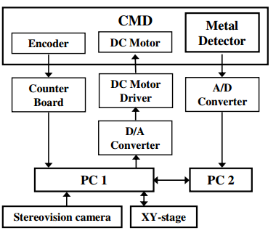

**Fig. 1 Architecture of CMD System**

The current algorithms being used in mining are not sufficiently handling data. To overcome this barrier, a faster algorithm has been introduced [7]. The proposed algorithm is better from previous conventional ones but there is a need to optimize this algorithm in terms of the automatically determined number of outliers, which have not been explained clearly.

Land mines are among the biggest reason of devastation in wars and also prove lethal in post war times. The basic concept for detection of mines is the detection of metals which are known to form the outer layer of mines [8]. However, this is not as easy as it seems because all the metals involved are extremely sensitive and explosive, ready to go off at the slightest of change in pressure [9]. Hence the target is to detect mines from a far distance that is

safely away from harm’s way. In the earlier times, animals were used to provide aid in mine detection. This has been replaced by automated detectors and mechanical tools in the modern era. Other methods have been the use of bacteira, acoustics or trained marine animals to detect mines [10].

Metal detectors are used for detecting the presence of metals in a nearby area. These can be used to detect metal that are present underground as well. These detectors usually have a unit that be handled manually and swept over object for detection. If the sensor registers a metal, it is indicated by means of change in tone or movement of the needle indicator [11]. There are also the ‘walk through’ detectors which are fixed in one place and generally used for security of airports, prisons or other important facilities. These detectors can sense the presence of metal and alert the security personnel. The most basic detector has an oscillator that produces an alternating current. This current can pass through the coil and produce a magnetic field. In case a metal is present nearby, eddy currents are produced in the metal which in turn initiates a magnetic field. This change in the magnetic field is due to the metallic object which can be detected [12].

Training of dogs for detection of mines has been common as trained dogs can sniff chemical and explosives. In case a trained dog comes across a mine, it immediately stops. This is a signal to the handlers that something has been detected. Safety has to be given consideration and the handlers only enter the field that the dog has signaled as clear. It has been seen that dogs can easily detect materials buried around up till six feet deep. Also, mines as old as 40 years can be detected by dogs. This is a faster approach then that involving humans working with metal detectors. Dogs can scan up till 800 square meters per day. Hence dogs are widely used to scan wide areas of lands, particularly those which are suspected to have mines. They can also detect mines in uneven areas such as steep grounds or rocky areas. Only the very dense vegetative areas prove a problem to dogs [13]. Apart from dogs, rats are also being used for detection of chemicals and explosives. In Mozambique, rats trained by APOPO are being used in the minefields. The term ‘hero RATS’ is being used for these rats. The advantage of using the African rats is their familiarity with the harsh climates and they only require very few resources for their growth. These African rats have a lengthy life span and work by being motivated for food in return. Different trainers can be used to train rats since they do not bond emotionally. Their tiny size is also an advantage, particularly in transportation. Rats can sense the smell of explosive and their weight is ideal as it does not set off the mines.

They indicate the presence of mines by scratching the ground. These locations are then marked and cleaned manually later by the demining teams [14].

# PROPOSED METHODOLOGY

The existing techniques have been kept in mind and the current proposal is designed to solve the existing shortcomings. The robot vehicle is proposed in order to curb the current problems faced in mine detection and clearance. Most importantly, the robotic vehicle is controlled by a detector that can be transported far and does not involve risk to human life. Even the tiniest metals can be detected by the robotic sensors. This detector is also very economical and uses very basic hardware that makes it easily available for all.

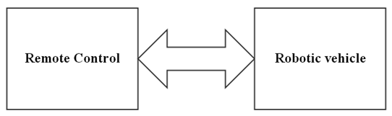

**Fig. 2 Initial Block diagram**

The proposed system comprised of two main block which are named as the Remote control and the Robotic vehicle, as shown in figure 2. The remote control block has the complete control of the entire system including the determination of the movement of the vehicle by means of wireless RF module. Also, this block has an LCD that is present on the remote control, aimed for determination of location coordinates once the mines have been detected by the robotic vehicle, which has a GPS attached. The robotic vehicle is the major detection block, it has a metal detecting hardware. The metal detector scans the field for the presence of metallic bodies and once a metal is detected, a signal is sent back to the remote control block by means of the GPS which conveys information about the exact location of the metal.

The proposed system is designed to be controlled from a safe control room that is far away from the mines. The movement of the detector robot can be controlled from the control room. Directions can be specified for the desired movements of the robotic vehicle. The vehicle can move in all directions and can also rotate and spin about its own axis in order to cover maximum areas. The presence of an LCD on the control system helps in displaying the coordinates that have been conveyed back by the robotic vehicle upon the successful detection of a landmine as shown in Fig. 3.

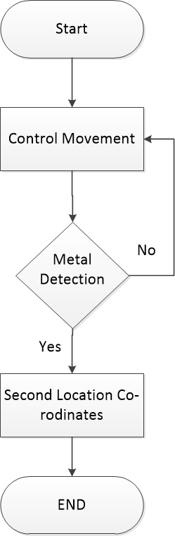

**Fig. 3 Flow Chart Diagram of Mine Detector**

**A. Robotic Vehicle**

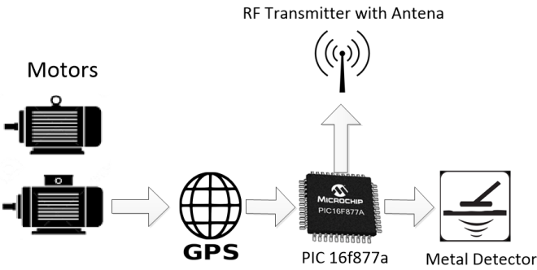

**Fig. 4 Schematic Diagram of Robotic Vehicle**

The robotic vehicle comprises of PIC16F877a as the central part of vehicle that is the metal detector and the RF and GPS are connected to this central part. Signals from the remote control are received by the RF transceiver as shown in figure 4. The movement of the vehicle is possible is various directions and it can send signals to the microcontroller which in turn sends signals for the movement of the vehicle to the motor driver. A normal speed of movement is followed by the vehicle and upon the detection of metallic objects, this can be stopped.

While the vehicle is moving, the detector scans the entire field for the presence of metallic objects. Even the smallest objects can be detected by the metal detector and signals are then sent to the microcontroller to stop the vehicle. As soon as the vehicle stops, PIC16F877a sends signals to the GPS in order to obtain the location coordinated in order to identify the exact location of the mines. The GPS communicated the location to the microcontroller and then to RF for transmission. Circuit diagram is shown in Fig. 5..

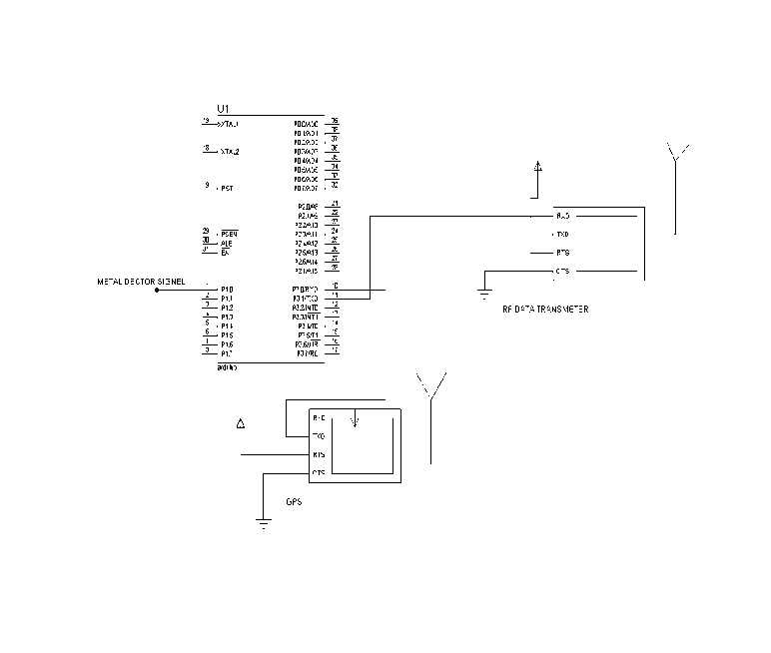

**Fig. 5 Circuit Diagram of robotic vehicle**

## Algorithm of Vehicle

**START**

Define Ports/Headers

Init Main

***-- MAIN RF Tx TRANSMITTER***

unsigned char data uart_send(void);

unsigned char data send_packet(void);

unsigned char data uart_send(void)

{

***-- Only send the new data after***

while(TXIF==0);

***-- The previous data finish sent***

TXREG = data ;

}

unsigned char data send_packet(void)

{

***-- Buffer for the data in one packet.***

unsigned char i;

unsigned char buffer[3];

***-- Byte 0 is Header and 1 is the data.***

buffer[1] = data;

buffer[2] = (unsigned char)(HEADER + data);

***-- Byte 2 is the checksum.***

for (i = 0; i < 7; i++) uart_send(SYNC_DATA);

***-- Transmit the packet using UART.***

for (i = 0; i < 3; i++) uart_send(buffer[i]);

}

**END**

## B. Control System

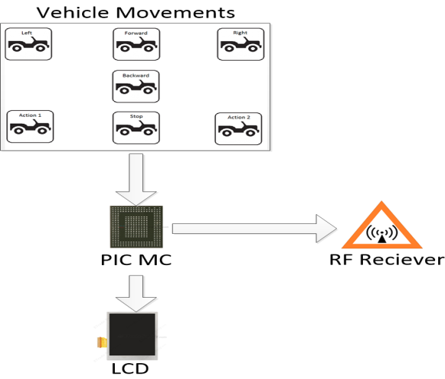

**Fig. 6 Schematic diagram of Control System**

The control unit comprises of the PIC 16f877a, an LCD and an RF transceiver as shown in figure 6. The main functions of the control system are to ensure the movements of the vehicle are controlled and then to correctly display the exact information about the location of the field as received from the vehicle. The commands are received by microcontroller and it subsequently transmits those commands through RF transmitter, the vehicle then moves. As soon as the vehicle identifies metal and stops, the RF receiver gets the coordinates of the location. These are sent to the microcontroller and then displayed on the LCD of the control system. Circuit diagram is shown in Figure 7.

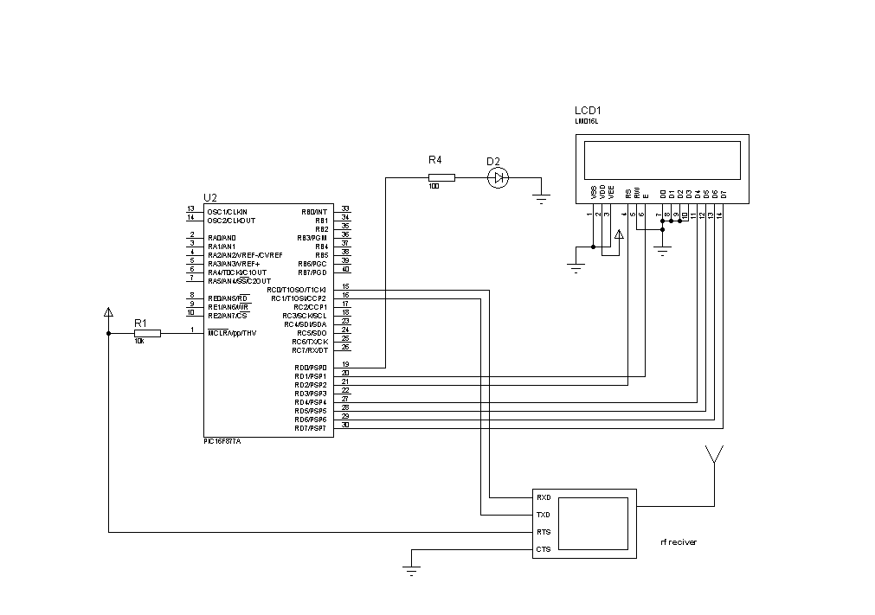

**Fig. 7 Circuit diagram of Control System**

## Algortihm of Control System

**START**

Define Ports/Headers

Init Main

***-- MAIN RF Tx TRANSMITTER***

#define send_button RA3

#define display PORTB

unsigned char data uart_send(void);

unsigned char data send_packet(void);

unsigned char data uart_send(void)

{

***-- Only send the new data after***

while(TXIF==0); TXREG = data ;

}

***-- The previous data finish sent***

unsigned char data send_packet(void)

{

**-- Buffer for the data in one packet.**

unsigned char i; unsigned char buffer[3];

***-- Byte 0 is the header.***

buffer[1] = data;

***-- Byte 2 is the checksum.***

buffer[2] = (unsigned char)(HEADER + data);

***-- Clocking for a while before sending the data so that the Tx and Rx are in sync.***

for (i = 0; i < 7; i++) uart_send(SYNC_DATA);

***-- Transmit the packet using UART.***

for (i = 0; i < 3; i++) uart_send(buffer[i]);

}

**END**

# CONCLUSIONS

It was once considered impossible to have an equipment that can control the movements of any vehicle and detect minefields. The model for mine detection is an important tool for IT and electronic engineers for building automatic systems in a short span of time. This mine detecting robot is designed to save time and precious lives. The previous techniques have been reviewed in great detail and we have tried to overcome the barriers that were existing in the previous methods. This robotic vehicle does to cut down the risks associated with mine detection. The wireless control system makes it safe and risk free. Also, the detector is extremely efficient and can detect the smallest piece of metal. This ensures that none of the mines remain undetected. Another important feature is the cost effectiveness; the simple materials used make is affordable.

This robotic vehicle can easily be customized and the developers can use applications to control the device. This system has to be evaluated in great depth in future as it holds very broad future perspectives. The accuracy, ease of use, timely detection and risk assessment have to be further evaluated. The speed of the system and the chances of errors have to be seen and tested.

# REFERENCES

1. Kim, Eleana J. "Toward an Anthropology of Landmines: Rogue Infrastructure and Military Waste in the Korean DMZ." *Cultural Anthropology* 31.2 (2016): 162-187.Hirose, Shigeo, and Keisuke Kato. *Robotics and Automation, 1998. Proceedings. 1998 IEEE International Conference on*. Vol. 2. IEEE, 1998.
2. Huang, Qing-Jiu, and Kenzo Nonami. "Humanitarian mine detecting six-legged walking robot and hybrid neuro walking control with position/force control." *Mechatronics* 13.8 (2003): 773-790.
3. Dawson-Howe, Kenneth M., and Tomos G. Williams. "The detection of buried landmines using probing robots." *Robotics and Autonomous Systems* 23.4 (1998): 235-243.
4. Nonami, Kenzo, et al. "Development and control of mine detection robot COMET-II and COMET-III." *JSME International Journal Series C* 46.3 (2003): 881-890.
5. Hirose, Shigeo, and Keisuke Kato. "Development of quadruped walking robot with the mission of mine detection and removal-proposal of shape-feedback master-slave arm." *Robotics and Automation, 1998. Proceedings. 1998 IEEE International Conference on*. Vol. 2. IEEE, 1998.
6. Huang, Qing-Jiu, and Kenzo Nonami. "Humanitarian mine detecting six-legged walking robot and hybrid neuro walking control with position/force control." *Mechatronics* 13.8 (2003): 773-790.
7. Dawson-Howe, Kenneth M., and Tomos G. Williams. "The detection of buried landmines using probing robots." *Robotics and Autonomous Systems* 23.4 (1998): 235-243.
8. MacDonald, Jacqueline, et al. *Alternatives for landmine detection*. No. RAND/MR-1608-OSTP. RAND CORP SANTA MONICA CA, 2003.
9. Nonami, Kenzo, et al. *Mine Detection Robot and Related Technologies for Humanitarian Demining*. INTECH Open Access Publisher, 2008. He, Zengyou, et al. "A fast greedy algorithm for outlier mining." *Pacific-Asia Conference on Knowledge Discovery and Data Mining*. Springer Berlin Heidelberg, 2006.
10. Rawlings, Douglas E. "Heavy metal mining using microbes 1." *Annual Reviews in Microbiology* 56.1 (2002): 65-91.
11. Douglas, Keith, and Mark Q. Meyer. "Apparatus having capacitive sensor and metal detector for detecting objects concealed behind surfaces." U.S. Patent No. 4,853,617. 1 Aug. 1989.
12. Fjellanger, Rune, E. K. Andersen, and Ian McLean. "A training program for filter-search mine detection dogs." *International Journal of Comparative Psychology* 15.4 (2002).
13. Poling, Alan, et al. "Using trained pouched rats to detect land mines: Another victory for operant conditioning." *Journal of applied behavior analysis* 44.2 (2011): 351-355.
14. Paik, Joonki, Cheolha P. Lee, and Mongi A. Abidi. "Image processing-based mine detection techniques: A review." *Subsurface Sensing Technologies and Applications* 3.3 (2002): 153-202.

**Authors Profiles**

** Hafiz Suliman Munawar** received his B.Sc Engineering degree in 2014 from UET Taxila, Pakistan and MS from Research Centre for Modeling and Simulation, National University of Sciences and Technology (NUST), Pakistan with a competent interest in multidisciplinary studies in 2016.Currently he is serving as Manager Operations in reputed R&D firm.

**Usama Khalid** is working as a Research Assistant in Telesehat Pvt. Ltd. Pakistan and received his BS (Software Engineering) degree from COMSATS Institute of Information Technology, Pakistan in 2016. He has been working on several research projects to optimize their performance.

**Dr. Adnan Maqsood** is working as Assistant Professor at Research Center for Modeling and Simulation, National University of Sciences and Technology (NUST), Pakistan, since 2012. He received his Bachelor degree in Aerospace Engineering from NUST, Pakistan in 2005 and PhD from Nanyang Technological University (NTU).